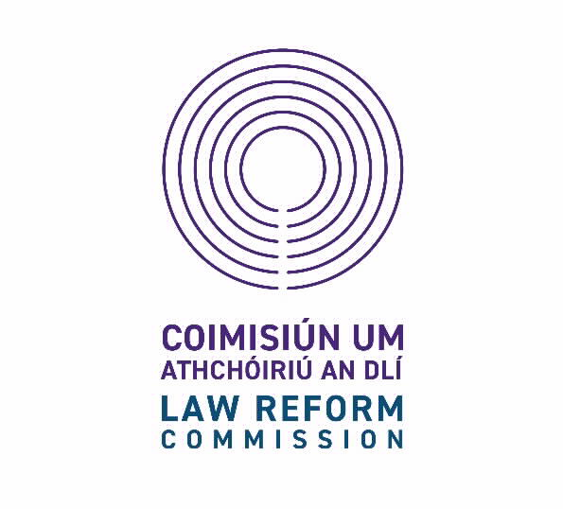

**Application Form A**

Legal Access Internship 2026

To note: Section A is for statistical and administrative purposes only and will not be given to the Selection Board.

* Together with Section B, Section A must be sent via email on or before Friday, 24 October 2025 to the following email address: [recruitment@dppireland.ie](mailto:recruitment@dppireland.ie), with your **initials** followed by “**LAI2026”** in the subject description.. You will receive acknowledgment via email within two working days. Please note Section A and B must be submitted in MS Word and PDF format.
* Please ensure you read the instructions for the completion of the Application form and complete all areas, in full.
* To ensure that you do not miss out on any email communication it is highly recommended that you check your spam and junk folder on a regular basis.
* The Office of the Director of Public Prosecutions (ODPP) as the host organisation recognises its responsibilities under the European Data Protection Regulation 2018, Data Protection Acts 1988 - 2018 and the Freedom of Information Act 2014.

|  |  |
| --- | --- |
| 1. **Title:** |  |
| 1. **First Name:** |  |
| 1. **Surname:** |  |
| 1. **Official Address:** |  |
|  |
|  |
|  |

|  |  |  |  |  |
| --- | --- | --- | --- | --- |
| 1. **Official Contact Details:** | Mobile No. |  | | |
| Email address (for all correspondence) |  | | |
| 1. **Do you require any reasonable adjustment(s)?** | | | Yes | No |
| 1. **If yes, please specify special reasonable adjustment(s)required:** | | |  |  |
|  | | | | |

|  |  |  |
| --- | --- | --- |
| **8. Irish language Proficiency:** | | |
| Do you have proficiency in the Irish Language? | Yes | No |
| 1. **References:**   **Please supply details of two referees. Referees will only be contacted if selected for the internship.**  **NB: Your current employer will not be contacted by us without your prior consent.** | | |
| **Name** | **Address** | **Contact Details** |
|  |  |  |
| **Name** | **Address** | **Contact Details** |
|  |  |  |

|  |  |  |
| --- | --- | --- |
| 1. **Candidates Organisation Preference:**   **Please select both your first and second choice preference from the list of organisations in which you would like to be placed should you be successful.**  **NB: Successful candidates will not necessarily be placed in their preferred organisation, but we will try to facilitate requests where possible.** | | |
| **Organisation** | **First Preference** | **Second Preference** |
| 1. Law Reform Commission |  |  |
| 1. Chief States Solicitors Office |  |  |
| 1. House of Oireachtas Service |  |  |
| 1. Office of the Attorney General |  |  |
| 1. Office of the Director of Public Prosecutions |  |  |

**End of Form A. If you have not already done so, please complete Form B.**