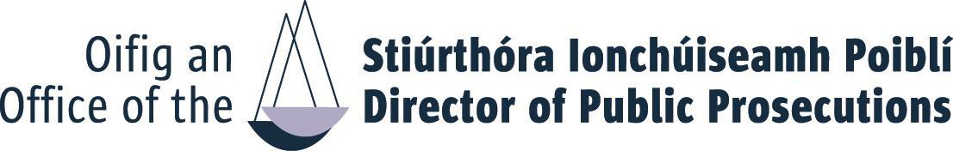
APPLICATION FORM
CLERICAL OFFICER (LEGAL AND CORPORATE SUPPORT) COMPETITION 2023

Completed Competency Assessment form should be submitted with your CV BY EMAIL to:
Recruitment@dppireland.ie
FIRST NAME
SURNAME
Please see Information Booklet for closing date and time.

E
: FIRST NAME: SURNAME
You must ensure that all sections of this application form are completed in full – please ensure to add your name to the header of this document
E MAIL:
TELEPHONE:

Competencies
Using the space below, with reference to each of the competency criteria set out in the competition notice, please highlight specific relevant knowledge, experience, skill or achievement or aptitude, which clearly demonstrates your suitability to meet challenges of a Clerical Officer in the Office of the Director of Public Prosecutions. It is recommended that candidates fully utilise the 400-word count to help demonstrate that they meet criteria for each competency.

Teamwork (Max. 400 words)

Delivery of Results (Max. 400 words)

Customer Service & Communication Skills (Max. 400 words)

Information Management/ Processing (Max. 400 words)

- Statement of Interest in support of your application: (Max. 500 words)

Please provide additional information NOT ALREADY referenced in your application which you
consider relevant in support of your application.

Please type over this and the box will expand as required.

☐ I hereby declare that I fulfil all the requirements set out in the Competition Notice
to fill a position at Clerical Officer level in the Office of the Director of Public
Prosecutions and that all the information given in this form is correct.
Name: Date:

