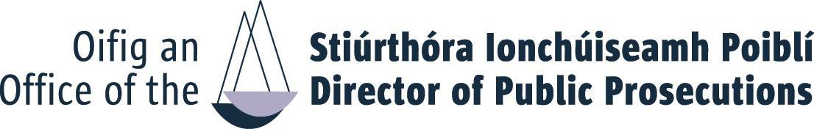
APPLICATION FORM
SENIOR PRINCIPAL PROSECUTOR COMPETITION 2023
Completed application form should be submitted BY EMAIL to:
Recruitment@dppireland.ie
Please see Information Booklet for closing date and time. If you don’t receive an acknowledgement within 24 hours you should contact the HR-OD by phone or email

TITLE: FIRST NAME: SURNAME
You must ensure that all sections of this application form are completed in full.
E MAIL:
TELEPHONE:

Academic/Technical/Professional Qualifications

Year & title of qualification(s) | Subject(s) taken in final year | Grade | Institution

Enrolment
Date of enrolment as a Solicitor to the State:

Enrolment Date: Enrolment Number:

Date Called to the Bar:

- Employment Record:

Outline below, starting with the most recent, full particulars of all employment or self-employment (including any periods of unemployment) between the date of leaving college and the present date. No period between these dates should be unaccounted for.

Date
Title

Date
Title

Date
Title

Date
Title

Date
Title

Date
Title

- Competencies
Using the space below, with reference to each of the competency criteria set out in the competition notice, please highlight specific relevant knowledge, experience, skill or achievement or aptitude, which clearly demonstrates your suitability to meet challenges of a Senior Principal Prosecutor in the Office of the Director of Public Prosecutions.

Criminal Legal Knowledge, Expertise and Self Development (Max. 400 words)

Judgement and Decision Making Skills (Max. 400 words)

Management and Delivery of Results (Max. 400 words)

Leadership and Strategic Direction (Max. 400 words)

Building Relationships and Communication Skills (Max. 400 words)

- Statement of Suitability in support of your application: (Max. 500 words)

Please provide additional information NOT ALREADY referenced in your application which you consider relevant in support of your application

I hereby declare that I fulfil all the requirements set out in the Competition Notice to fill a position at Senior Principal Prosecutor in the Office of the Director of Public Prosecutions and that all the information given in this form is correct.
Name: Date:

