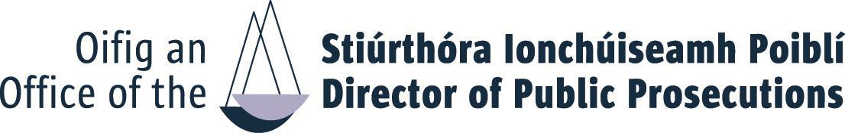
APPLICATION FORM
HEAD OF GOVERNANCE AND PUBLIC AFFAIRS COMPETITION 2023
Completed application form should be submitted BY EMAIL to:
Recruitment@dppireland.ie
Please see Information Booklet for closing date and time. If you don’t receive an acknowledgement within 24 hours you should contact the HR-OD Unit by phone or email
FIRST NAME

TITLE

SURNAME
E
: FIRST NAME: SURNAME
You must ensure that all sections of this application form are completed in full.
E MAIL:
TELEPHONE:

- Competencies
Using the space below, with reference to each of the competency criteria set out in the competition notice, please highlight specific relevant knowledge, experience, skill or achievement or aptitude, which clearly demonstrates your suitability to meet challenges of Head of Governance and Public Affairs (PO) in the Office of the Director of Public Prosecutions.

Specialist Knowledge, Expertise and Self Development (Max. 500 words)

Judgement and Decision Making Skills (Max. 500 words)

Management and Delivery of Results (Max. 500 words)

Leadership and Strategic Direction (Max. 500 words)

Building Relationships and Communication (Max. 500 words)

- Statement of Suitability in support of your application: (Max. 500 words)

Please provide additional information NOT ALREADY referenced in your application which you consider relevant in support of your application having regard to the Office’s Strategy Statement.

I hereby declare that I fulfil all the requirements set out in the Competition Notice to fill a position at Head of Governance and Public Affairs in the Office of the Director of Public Prosecutions and that all the information given in this form is correct.
Name: Date:

