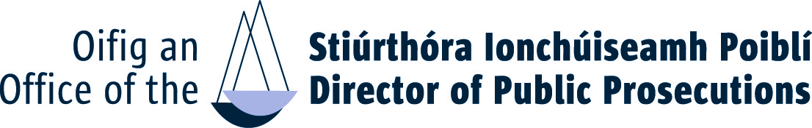

APPLICATION FORM
COMPETITION FOR APPOINTMENT AS
LEGAL & KNOWLEDGE MANAGEMENT RESEARCHER
IN THE OFFICE OF THE DIRECTOR OF PUBLIC PROSECUTIONS

Closing Date 3:30pm on 2 July 2021

Completed application form should be submitted BY EMAIL to
HR.mailbox@dppireland.ie
not later than 3:30pm on 2 July 2021. If you do not receive an acknowledgement within 24 hours you should contact the HR & Training Unit at
087 997 7540, 087 719 6113, 087 227 5029, 087 333 2209

 | TITLE |  | FIRST NAME |  | SURNAME
 | ADDRESS
 | E-MAIL
 | TELEPHONE

You must ensure that all sections of this application form are completed in full.

1. Education, Learning and Training Achievements

1. Academic/Technical/Professional Qualifications:
Date obtained and Full Title of Degree(s)/ Qualification(s) held | Subject(s) taken in final examination | Grade obtained (e.g. 1, 2.1, 2.2, Pass, etc.) | University, College or Examining authority

2. Employment Record:
Outline below, starting with the most recent, full particulars of all employment or self-employment (including any periods of unemployment) between the date of leaving college and the present date. No period between these dates should be unaccounted for. (NOTE: The table below will expand as you type).

Dates |  | Title of post and employer details/self-employment status | Main responsibilities and significant features of the post
From | To

2. Competencies
Using the space below, with reference to the applicable competency criteria as set out in Appendix 1 of the Information Booklet, please highlight specific relevant knowledge, experience, skill or achievement or aptitude, which clearly demonstrates your suitability to meet the challenges of a Legal & Knowledge Management Researcher in the Office of the Director of Public Prosecutions.

Specialist Knowledge, Expertise and Self Development
Please include details of your relevant experience of legal knowledge management and legal research, including any experience which demonstrates your knowledge of Irish law, the Irish legal system and EU law (Max. 300 words)

Analysis and Decision Making
Please include details of your information technology skills and knowledge and experience of legal information resources, databases and research tools and how you use these tools to assist in carrying out legal analysis and providing reliable legal research conclusions (Max. 300 words)

Delivery of Results
Please provide examples of how you have prioritised and managed workloads and achieved deadlines / met defined performance targets, whilst maintaining quality (Max. 300 words)

Interpersonal and Communication Skills
Please outline your experience of working independently and /or as part of a team (Max. 300 words)

6. Please give below any other relevant information in support of your application (Max. 300 words)

I hereby declare that I fulfil all the requirements set out in the Competition Notice to fill a position as Legal & Knowledge Management Researcher in the Office of the Director of Public Prosecutions and that all information given in this form is correct.
Name: Date:

Application Form to Be Returned by Email to “HR.mailbox@dppireland.ie”

